**Digital marketing**

**Assignment -1**

**Topic:-Memes from different brands that iscollaborated together.**

**1.Purity coffee**

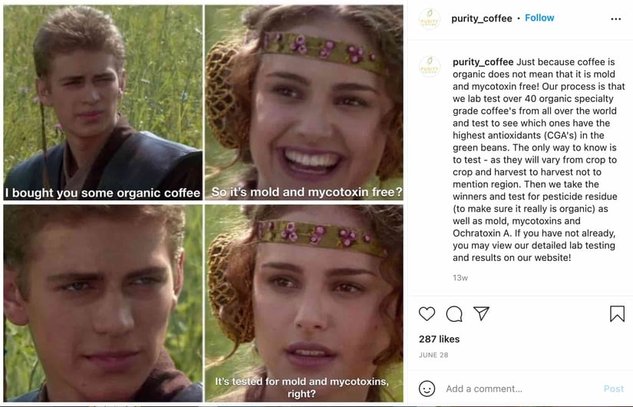

This meme came from the 2002 Star Wars film, "It shows a conversation between two people as one says something that brings happiness and excitement to the other. That is until they realize it may not be so great after all.Coffee brand Purity Coffee not only educates its audience on an issue they may not be aware of but also boosts its own value in the process.As shown in example, memes offer a great opportunity to highlight issues that your brand helps resolve or address

**2.Yappy**

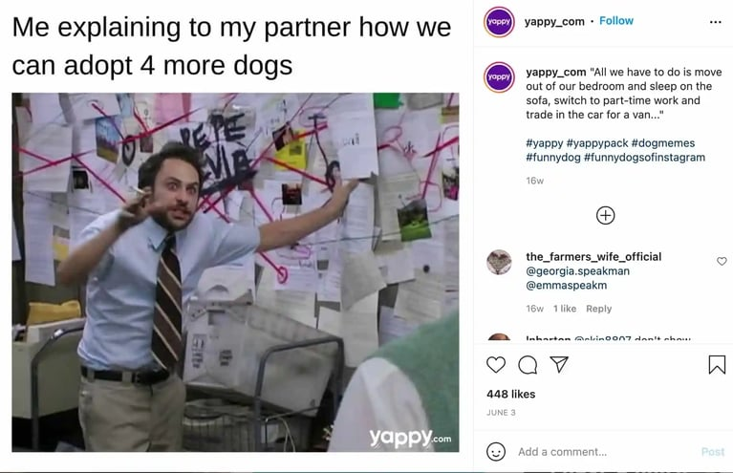

In this example, pet store brand Yappy pokes fun at its core audience, likely animal lovers who have a constant desire to adopt pets.

When you know and understand your user persona, you can create memes that really resonate with your audience, leading to higherengagement rates.

**3.Prime video**

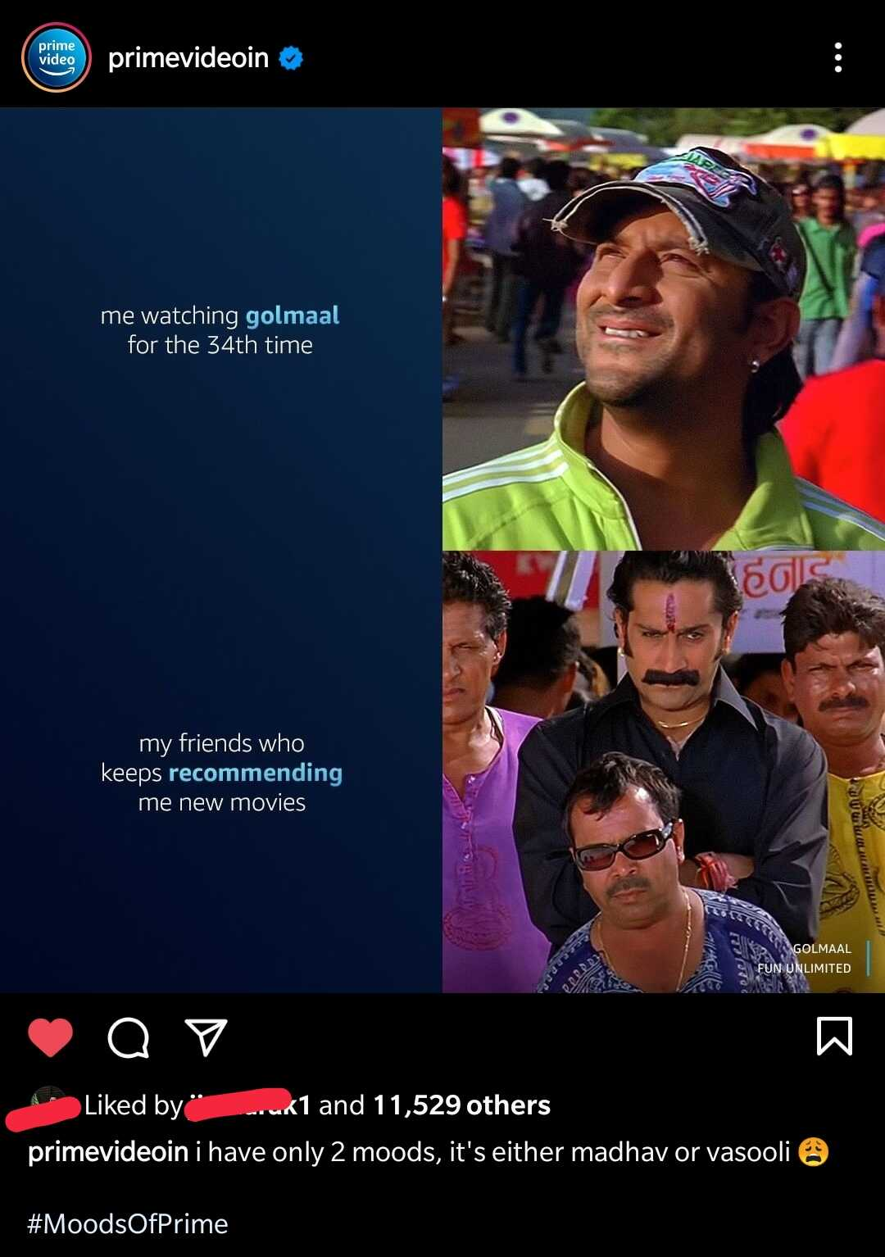

Prime Video is a streaming platform by Amazon where you can watch various types of Movies / Web series, they post memes to promote upcoming movies/ Web series or already streaming content! here we can see they used the most popular Golmaal Meme Templates

**4.Big Bazzar**

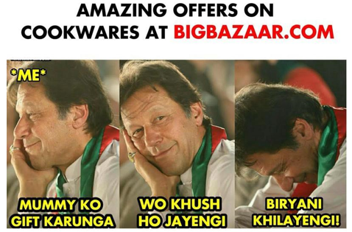

The retail company used a meme based marketing strategy to promote their ecommerce platform. Their took the seen in one movie and made meme on it funny to reach their customers.They used the Bollywood,IPL,shows etc.

**5.zomoto**

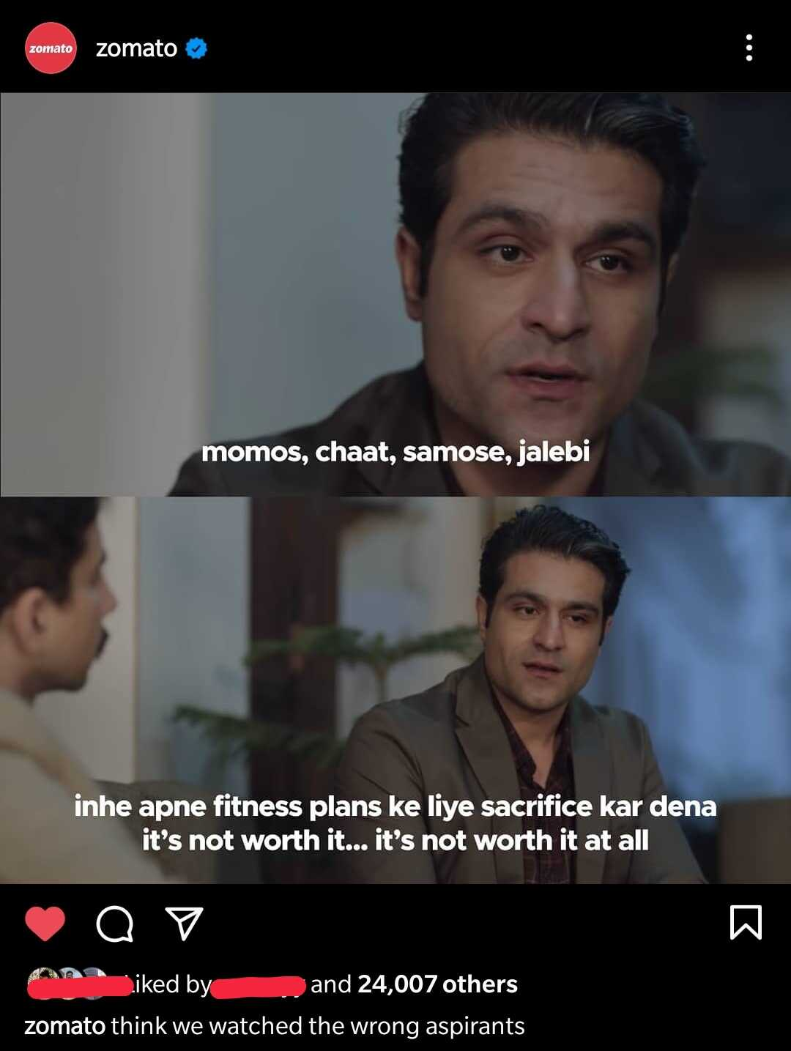

Zomato is a very popular food aggregator platform that includes not only Delivery but also Cloud kitchen and many more services. they also use memes to engage with their customers by using trending topics and also for awareness! Here they used Meme Template from the Popular Web series